Server Running :

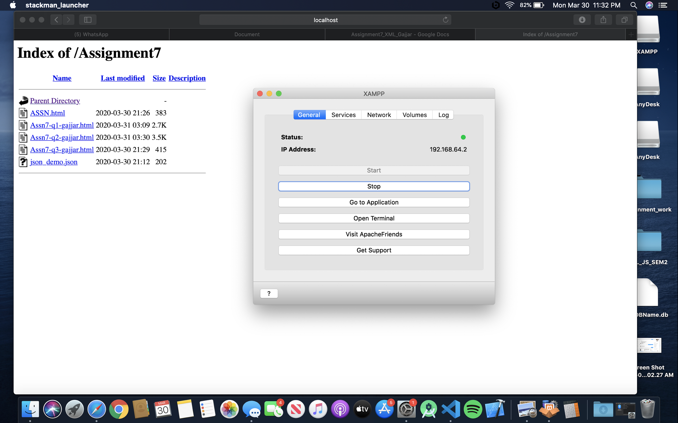

1.

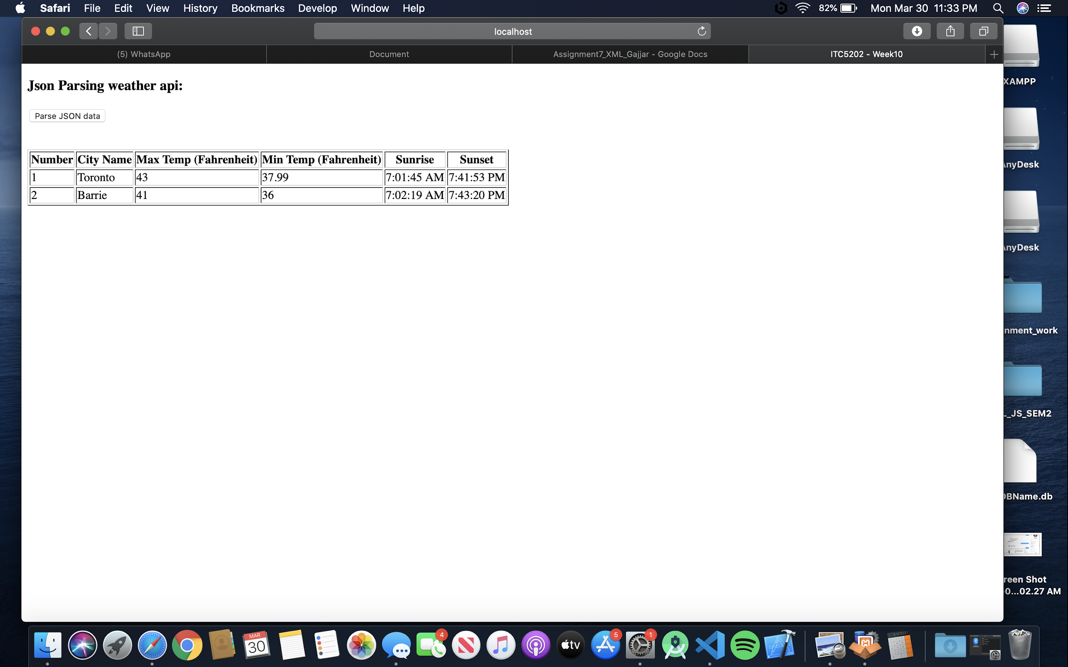

2.

Could have used function for dymanic city text but will keep it for as its small scenario in code

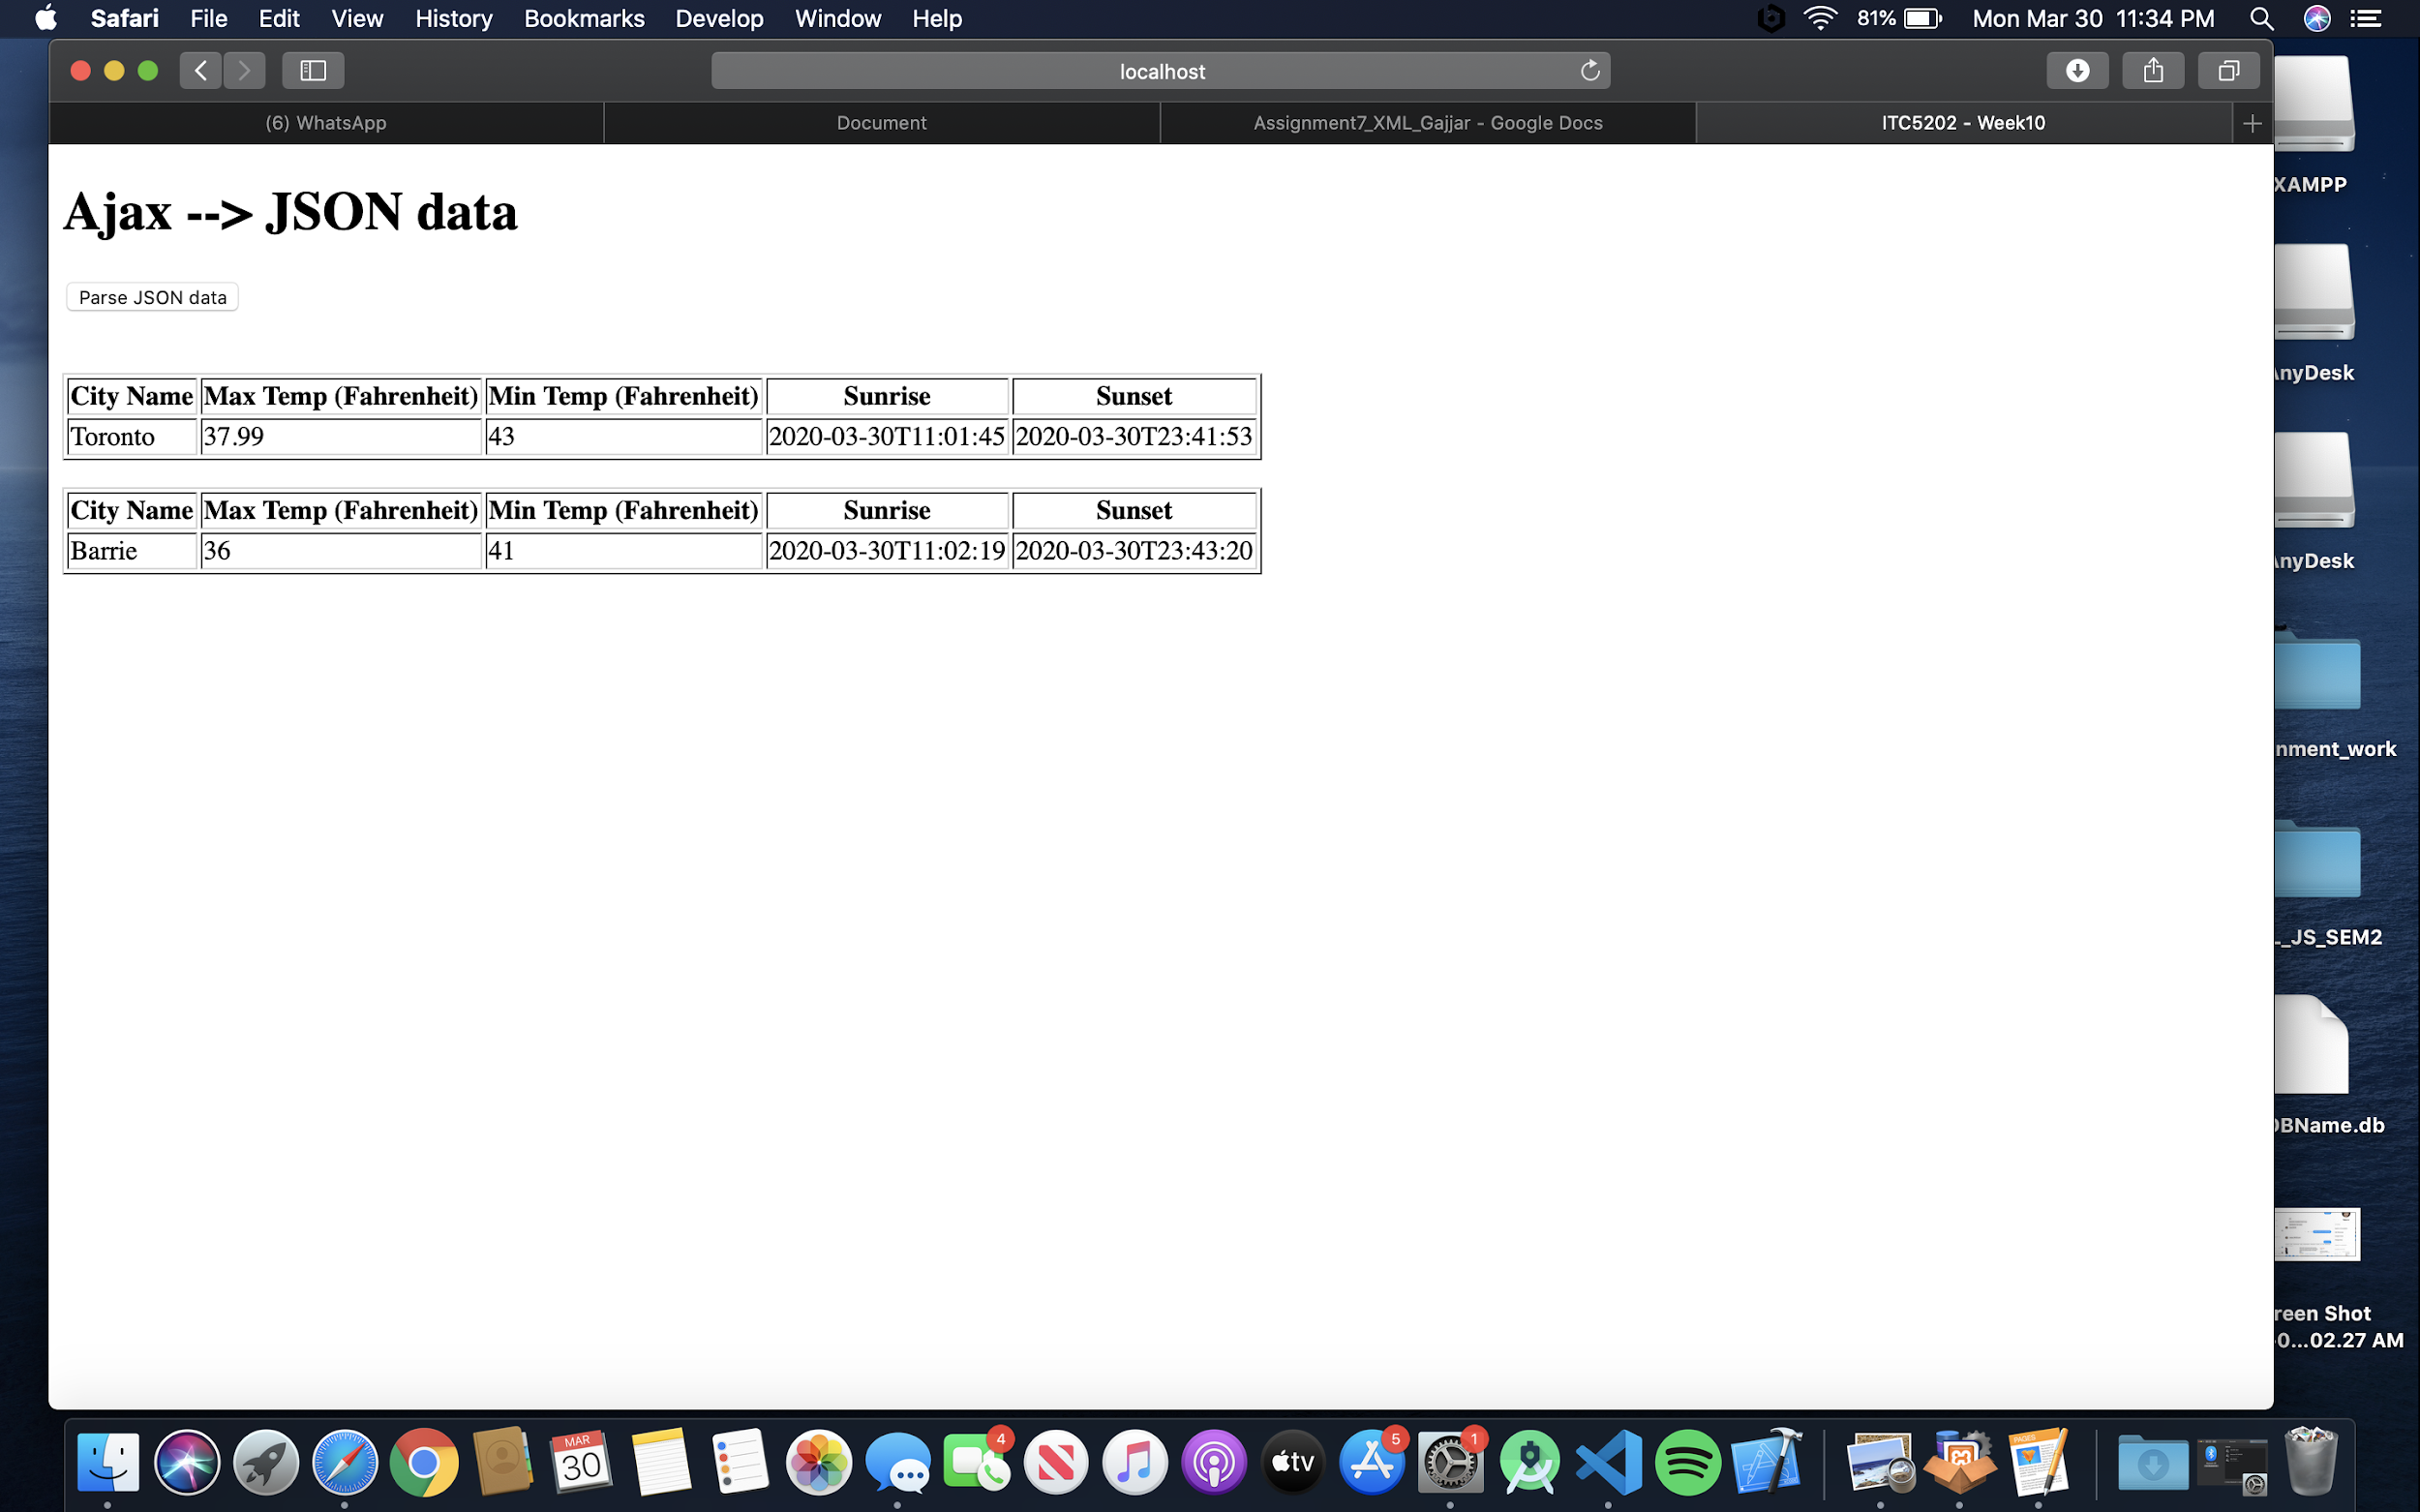

3

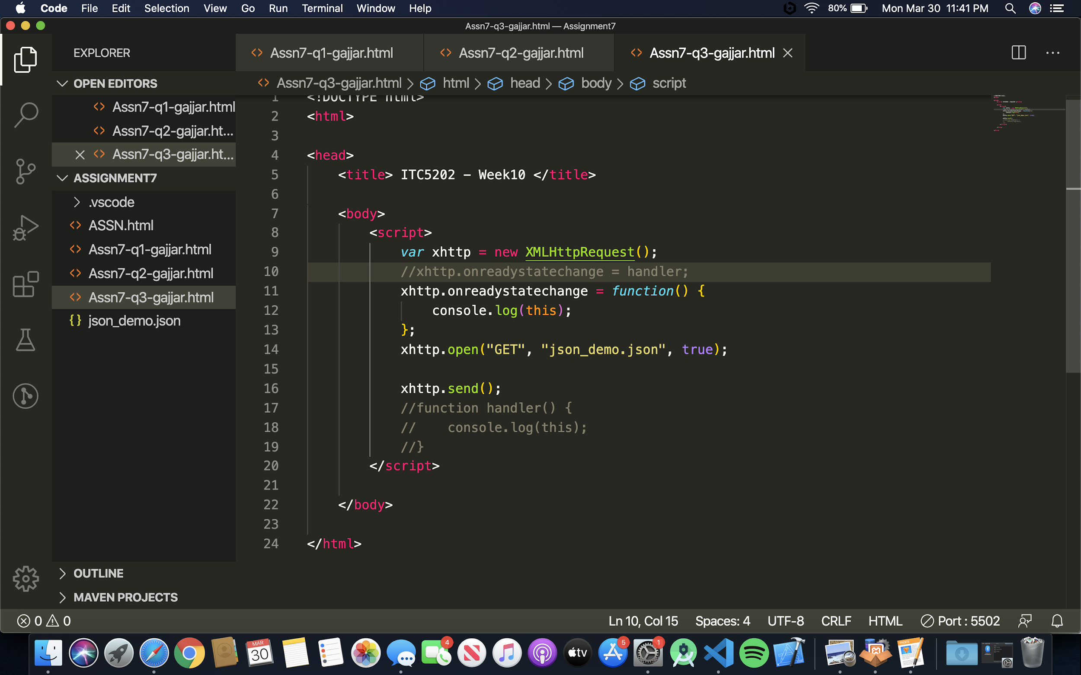

Step 1:

First a new Object is created of XMLHttpRequest() type.

Then the request is Opened and Sent further

True means that request is Asynchronous

Step 2:

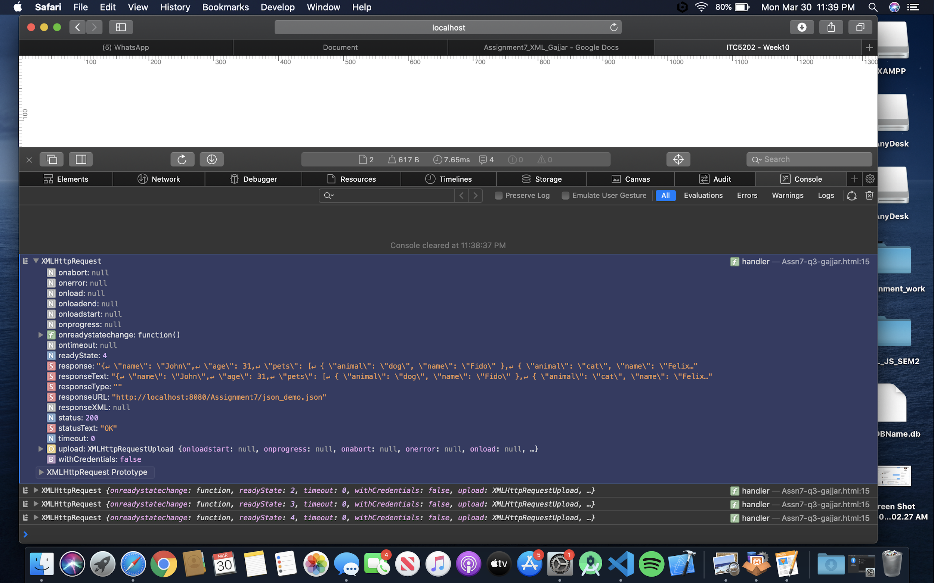

This gives the XMLHttpRequest object.

If we print it by console.log it will show us the changes in the state

Step : 3

This.status return code 200 which means the request was successful.

The HTTP **200** is OK success status response **code**

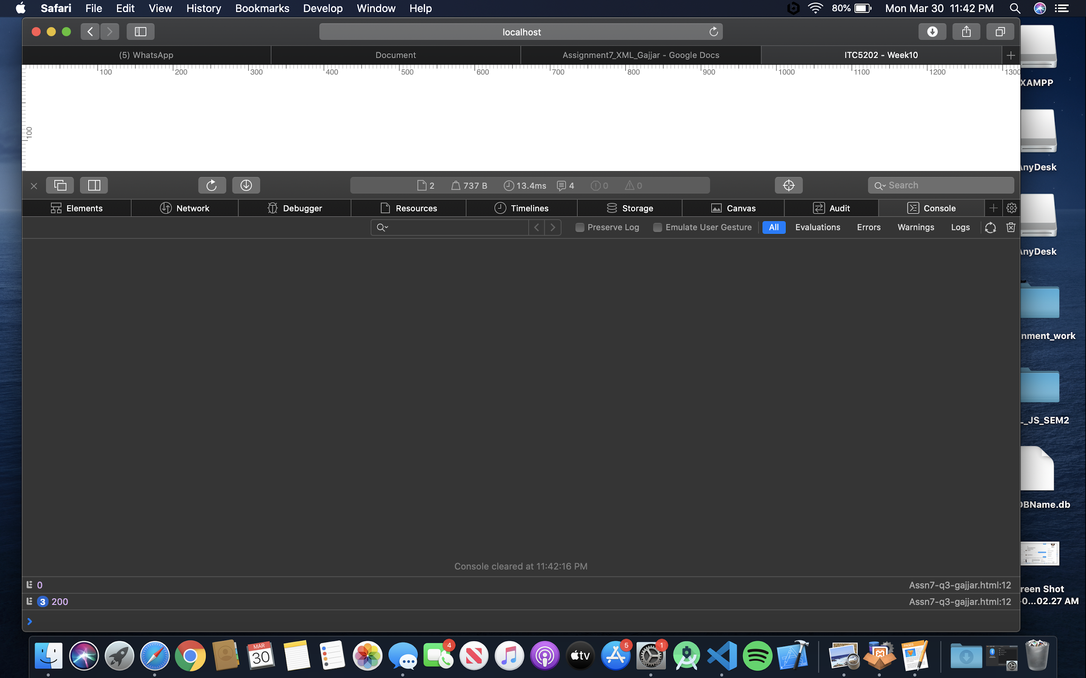

Handler :

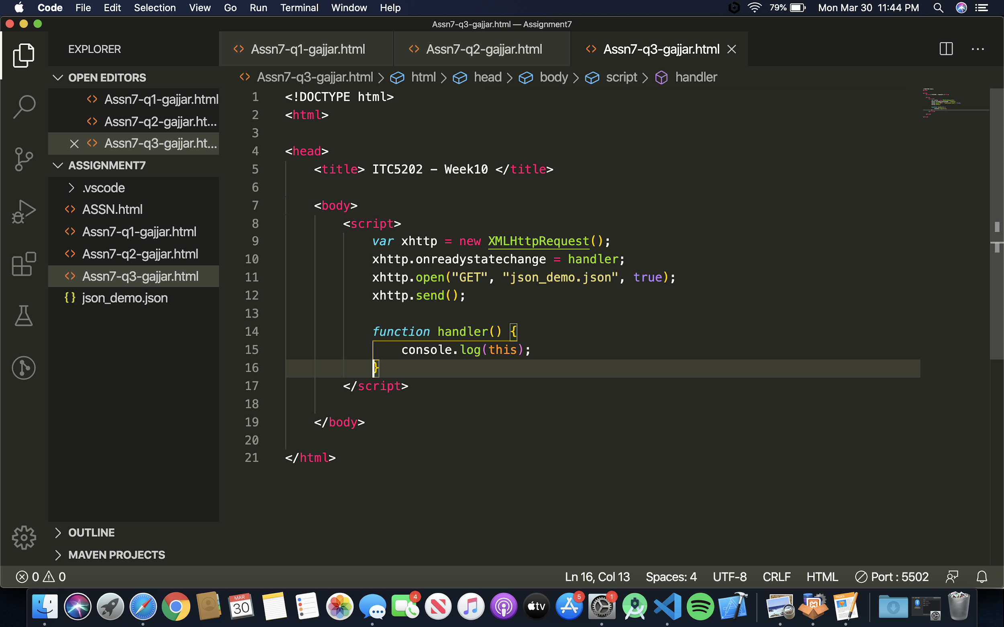

Both the scripts are almost same only difference is the functions name given in one and not in other.